40 Watt DC/DC Converters with
Improved Cost & Performance
in high-density 1x2” footprint
San Jose, Calif. – October 30, 2019 – TRACO POWER announces their new TEN 40E and TEN 40WIE families of 40 watt high-density DC/DC Converters optimized to reduce cost and improve performance in the industry standard 1” x 2” footprint.

The primary difference between these two families of DC/DC converters is the TEN 40E has wide 2:1 input ranges of 9-18 / 18-36 / 36-75 VDC versus the TEN 40WIE series with 4:1 ultra-wide input ranges of 9-36 / 18-75 VDC. Each family offers 5 single outputs of 3.3 / 5 / 12 / 15 / 24 VDC and three dual outputs of ±12 / ±15 / ±24 VDC. Standard features include: 1600 VDC isolation; high efficiency operation up to 93%; remote on/off control; output voltage trim;
-40C to +85C operating temperature range (see derating); >1.2 million hours MTBF; and protection circuits for over-voltage / over-current and continuous short-circuit with auto-recovery. All models are backed a 3-year product warranty and safety approved to EN / IEC / UL 62368-1. Typical applications include industrial equipment, instrumentation, information technology and any distributed power architecture where weight and space are critical on the PCB.

Products are in stock and available through the TRACO POWER global distribution network with manufacturing lead times of 12-14 weeks. Please see www.tracopower.us/ten40e for specifications, drawings and safety documentation.
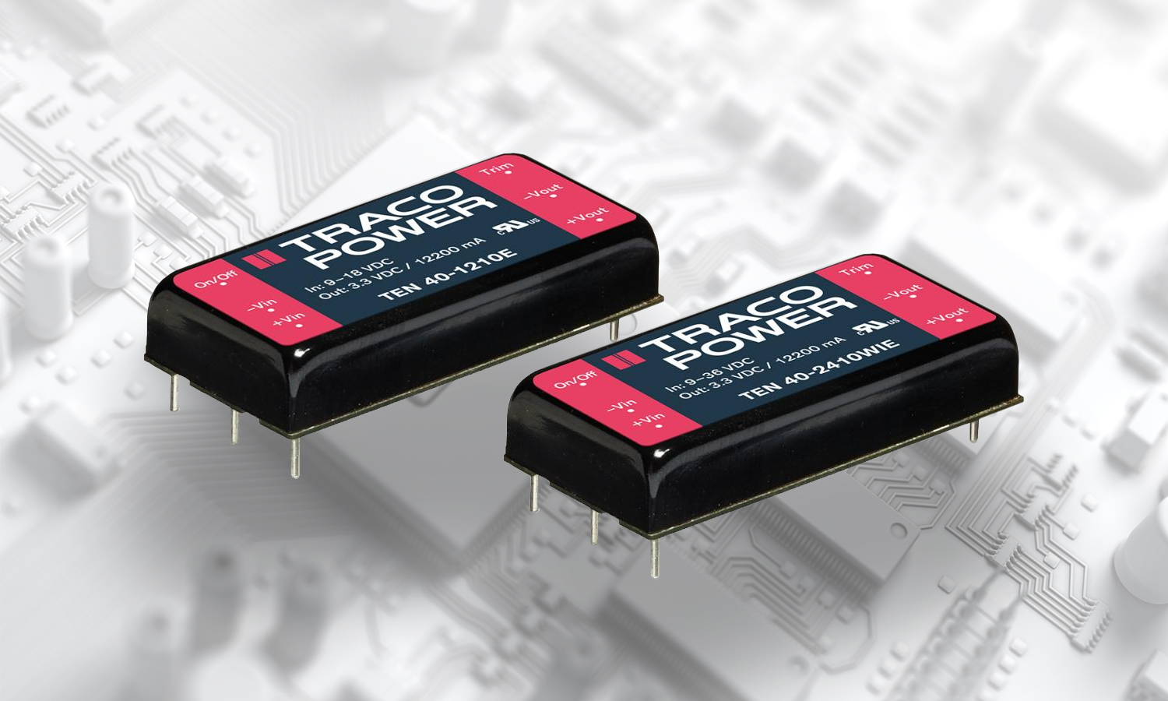

For further information and reader enquiries:

Paul Christiansen, TRACO Power North America, Inc.
2025 Gateway Place #330, San Jose, CA 95110

Office: +1 (408) 916-4570 Email: p.christiansen@tracopower.com
Fax: +1 (408) 916-4571

For further information, text and graphics by email or to discuss feature article opportunities:

Gorden Mack, Info-Mgt.net, 34786 Blackstone Way, Fremont CA 94555
Tel: (408) 821-8283 E-mail: gmack@info-mgt.net

Note to editors:

Power supply specialists, Traco Power is headquartered in Zurich, Switzerland. Offering more than 25 years of experience in power, Traco Power is dedicated to the design and manufacture of high-quality DC/DC and AC/DC power conversion products. Traco Power’s mission is to provide customers with the optimal power supply solution in terms of performance, quality and price. Traco Power’s commitment to quality is supported by a 3 or 5 year product warranty on all products.

